Experiential Learning
P.G DEPARTMENT OF BOTANY

The department follows a student centric approach and the interest of the student is kept at the centre for all policies adopted by department.
Methodologies used for enhancing learning experiences of students.

- Experiential learning,
- Participative learning
- Problem solving mehods

2022-2023
PG Department of Botany of HMV Organized “Alumni Lecture Series” (19 Nov, 2022)

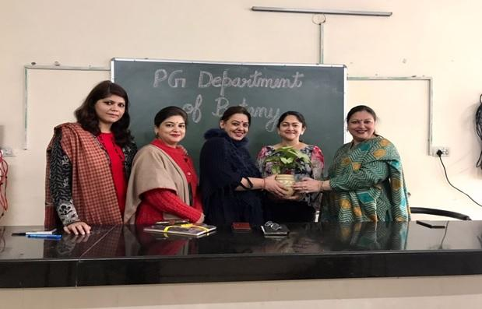
With the able guidance of Principal Prof. Dr. (Mrs.) Ajay Sareen, DD Pant Botanical Society of PG Department of Botany, Hans Raj Mahila Maha Vidyalaya, Jalandhar under “Alumni Lecture Series” organize lecture of Mrs. Kuldeep Kaur, alumni of Botany Department (2007-2008 Batch). Lecture started with floral welcome of Mrs. Kuldeep Kaur by Dr. Anjana Bhatia, Head of Botany Department, Dr. Shaveta Chauhan, Dr. Nitika Kapoor, Mrs. Ramandeep, Ms. Harpreet Kaur and Dr. Shuchi Sharma followed by introductory remarks by Dr. Anjana Bhatia. At present Mrs. Kuldeep Kaur is working as Senior Analyst for New York State Department of Health. She shared her work experience as Health Analyst at New York with students. She motivated students to work hard to achieve their dreams. Students also interacted with her and asked their queries related to various carrier options after doing M.Sc. (Botany). After lecture she also visited labs and class rooms of Botany Department where she recalled her student life and appreciated the up gradation of infrastructure including ICT enabled classrooms and advanced scientific instruments in the laboratories. Principal Prof. Dr. Ajay Sareen congratulated the department for organizing “Alumni Lecture Series” that provide platform for interaction of new generation students with their seniors. These types of interactions are quite beneficial for students in shaping their carrier through providing awareness about various carrier opportunities to them. At last Dr. Nitika Kapoor, Incharge, DD Pant Botanical Society presented vote of thanks.

Participative Learning

World Ozone Day celebrated at HMV (16 September, 2022)

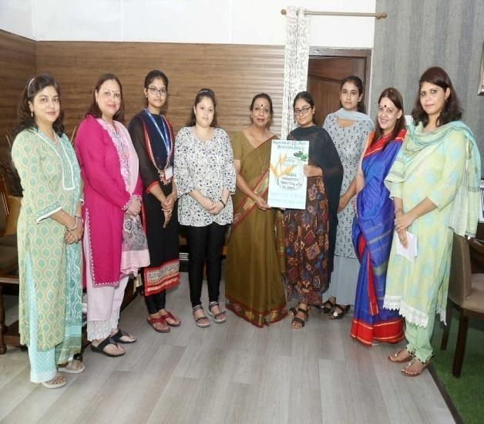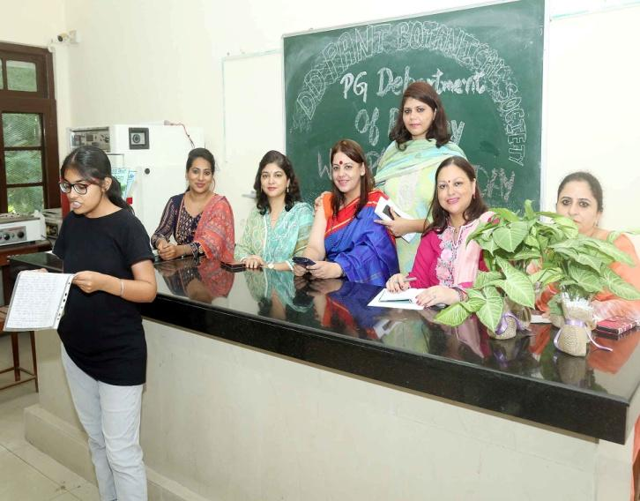
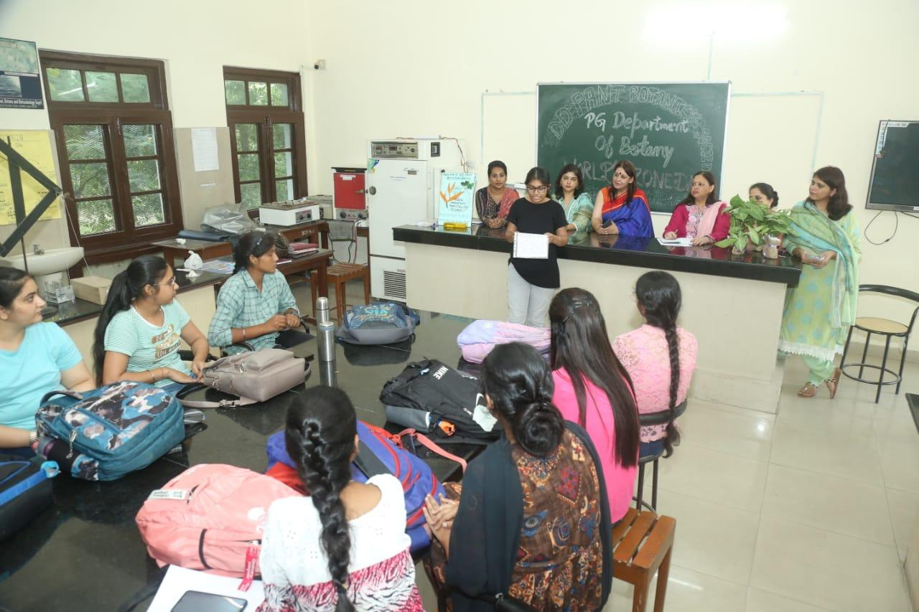
Under the able guidance of Principal Prof. Dr. Ajay Sareen, DD Pant Botanical Society of Hans Raj Mahila Maha Vidyalaya, Jalandhar celebrated World Ozone Day by organizing Declamation contest for college students. Students expressed their views on theme of world ozone day “Global co-operation for protecting life on earth”. All the students and faculty took pledge to co-operate with each other to protect life on our planet earth and save mother nature. Principal Prof. Dr. (Mrs.) Ajay Sareen highlighted the importance of Ozone day and motivated the students to adopt sustainable mode of life. Further Dr. Anjana Bhatia, Head of PG Department of Botany, urged students to connect with plants and nature. She also encouraged the students to plant more and more trees around their surroundings. The judgment of declamation competition was made by Dr. Shaveta, Dr. Nitika and Mrs. Ramandeep from PG Department of Botany. Dr Nitika Kapoor, Incharge, DD Pant Botanical Society presented vote of thanks and declared the names of the winners of Declamation contest. Ms. Aditi, M.sc. (Botany) Sem I and Ms. Navreen, B.Sc. BT (Sem III) secured first position, whereas Ms. Anisha, B.Sc. BT (Sem V) stood second in declamation contest. Third position in declamation contest shared by Ms. Shreya, M.Sc. (Botany) Sem I and Muskan Rana, M.Sc. (Botany) Sem III. On this occasion Dr. Shuchi Sharma and Ms. Harpreet were also present.
DD Pant Botanical Society of HMV Organized Nature Study Camp

Under the able guidance of Principal Dr Ajay Sareen, HMV, Jalandhar organized Nature Study Camp under Environment Education Programme with the support of Punjab State Council for Science & Technology as the State Nodal Agency and Ministry of Environment & Climate Change (MoEF & CC) as the catalysing and supporting agency for the Environment Education Programme.

Department of Botany and DD Pant Botanical Society of Hans Raj Mahila Maha Vidyalaya organizd a Nature Study Camp under Environment Education Programme with the support of Punjab State Council for Science and Technology as the State Nodal Agency and Ministry of Environment and Climate Change as catalyzing and Supporting agency. During this camp 24 students of M.Sc. (Botany) Sem 2 and 4 and B.Sc. (Medical) Sem VI visited Harike and Karmowal. At Harike Project Incharge Madam Geetanjali briefed the students about the various Water parameters they are studying at the confluence of Satluj and Beas at Harike. They also monitor the fauna present in the river like Indus Dolphin and Ghariyal. They also look for migratory birds visiting here from November to February. Ms. Sarabjeet also briefed students about Raptors found in Punjab. Principal Prof. Dr. (Mrs.) Ajay Sareen congratulated the department for its efforts in bringing awareness among students about Biodiversity and its conservation. On the second day of Nature Study Camp 24 students of M.Sc. (Botany) and B.Sc. (Medical) Sem-4 visited Van Chetna Park, Nara Dam and Saleran Dam which comes under Hoshiarpur Forests area. At 11.30 am in morning students reached at Van Chetna Park, to study floral Diversity in Park where Mr. Jasveer (Forest Inspector and Ms. Hashika (Block Incharge) briefed about necessity of environment protection. They also explained the motive of making such protected areas in Punjab. Then under the guidance students also visited Nara Dem, to enjoy Beauty of Nature. On the way students monitored the floral diversity in Nara Forest. They also enjoyed refreshment at ancient piece of art “Nara Rest Houre” constructed by British. After having lunch, students along with their teachers enjoyed beauty of Saleran Dam situated at latitude and surrounded by mountains. Principal Prof. Dr. (Mrs.) Ajay Sareen congratulated the department for putting their efforts to learn students outside the college boundaries. Dr. Anjana Bhatia, Mrs. Ramandeep Kaur, Ms. Harpreet and Dr. Shuchi accompanied the students.

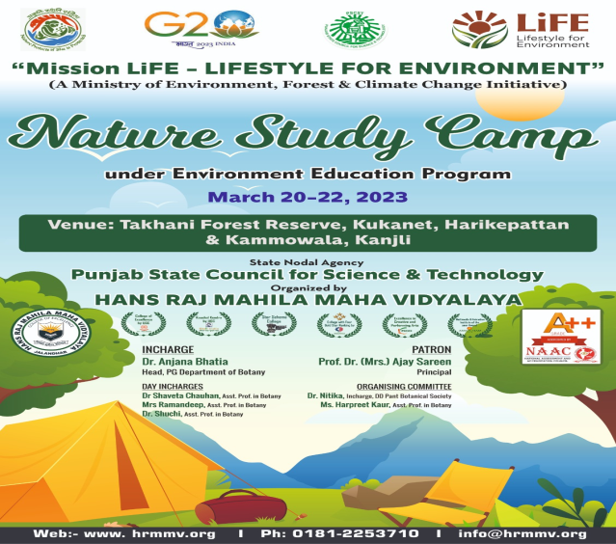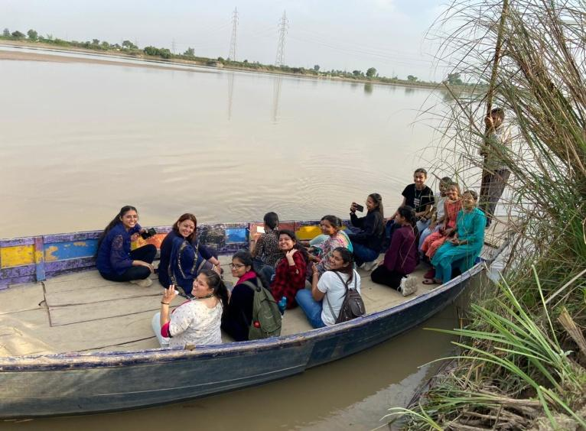

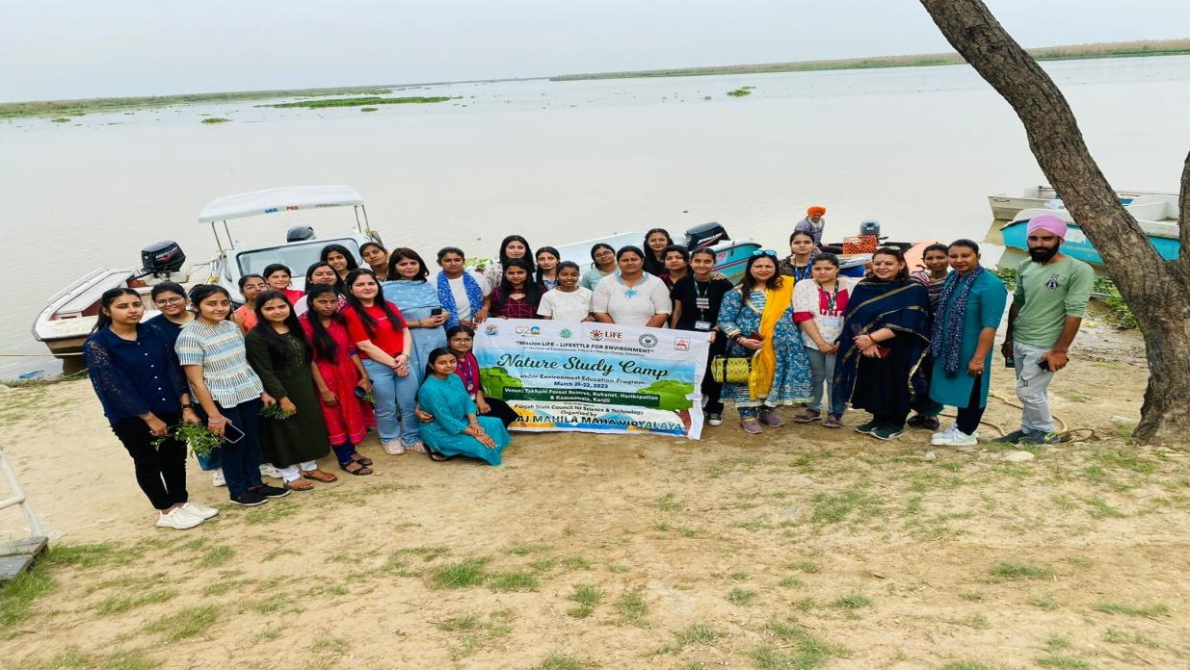
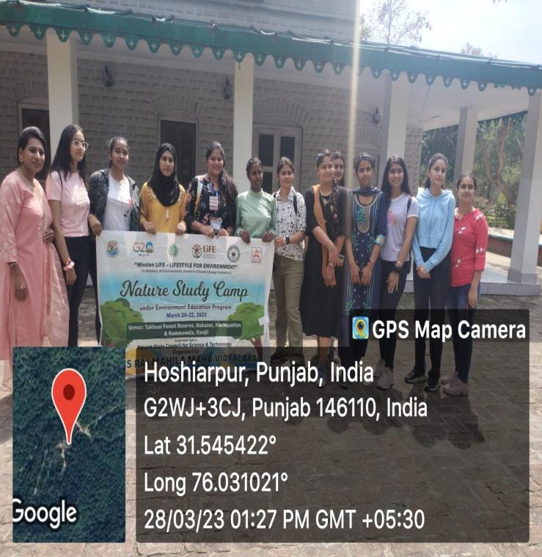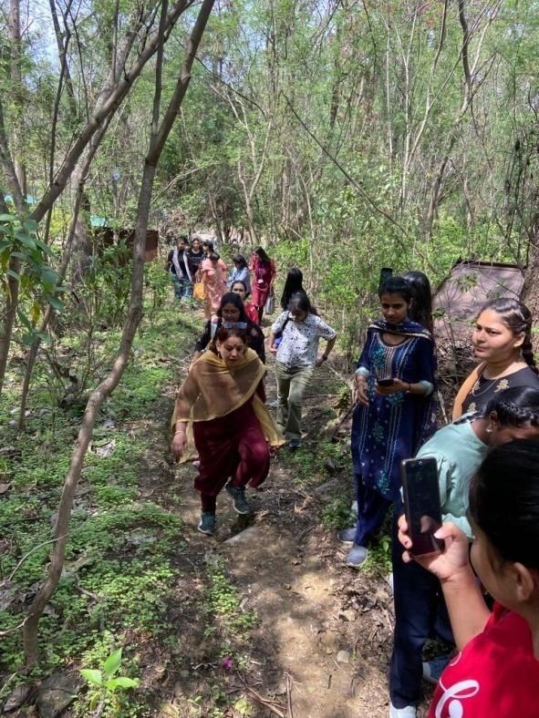

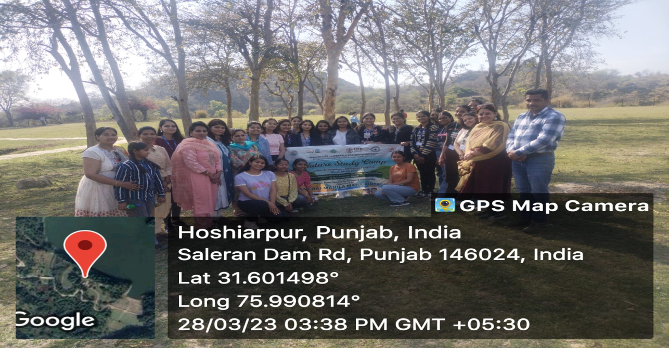

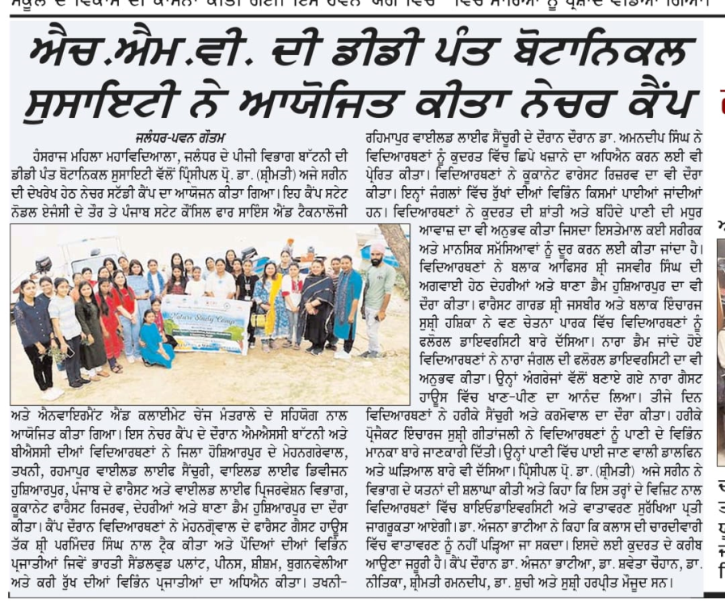
HMV Conducts E-seminar on Biodiversity Day
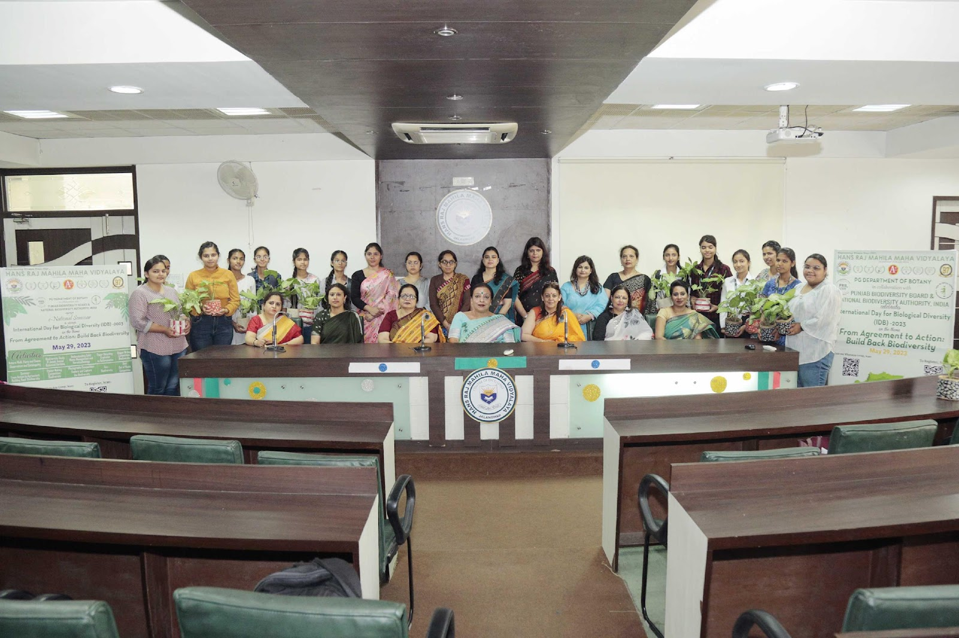

HMV College for Women has always been on the fore front in inculcating the all-round development qualities socially, intellectually and emotionally. The biodiversity day was celebrated and conducted at the college campus under the able guidance of Principal Prof Dr. (Mrs.) Ajay Sareen with the collaboration and presentation at the World Bank Level for the Biodiversity Day with the motto: Agreement to Act through an E-seminar at International Level IDP-2023. The programme commenced with the opening as the Gayatri Mantra and the lamp lighting, seeking the blessing of the Almighty. This was followed by the DAV song as the source of inspiration. The Chief Guest Dr. Jitendra Kaur Arora, Executive Director, Punjab State Council for Science and Technology, Secretary Punjab Biodiversity Board enlightened the sources of biodiversity. The second guest was Dr. Harminder Singh, Joint Director, Environment and Climate Change, Punjab Biodiversity Board. To add to this our special speaker. Sh. Amneet Singh, IFS, DFO, Hoshiarpur. They were all welcomed by Principal Prof Dr. (Mrs.) Ajay Sareen, Dr Seema Marwaha Dean Academics and School Coordinator, Dr. Anjana Bhatia, Dean Innovation and Research and Head of Botany Department were presented green planters. Principal Prof. Dr. (Mrs.) Ajay Sareen welcomed all the Resource Persons too and added that HMV College for Women is always a step up and takes up all positive measures to restore biodiversity and is ever ready in all its possible ways of Protection and Restoration of the Ecology and Biodiversity around us. The honourable guest of the day, Dr. Jitendra Kaur Arora also stressed upon the importance of biodiversity in all its spheres and laid stress on the ways and uses of its perfection protection and preservance and discussed all the positive ways of its Restoration and revival. Dr. Gurminder reflected on the spheres of biodiversity and its rule as well as importance on this green planet by uplifting and projecting the ways of living. Dr. Anjana Bhatia thanked all the guests for their valuable guidance and the fruitful points learnt through this seminar by their precious presence today. Dr. Seema Marwaha expressed gratitude for all the guests, Principal Prof. Dr. (Mrs.) Ajay Sareen, for her whole hearted guidance and support, Dr. Anjana Bhatia, all the staff members and the participants who have all worked collaboratively to make it a rocking success at such a high level.

